**Etta Gardner - Health Clearances**

Orthopedic Foundation for Animals: [Etta](https://www.ofa.org/advanced-search?f=sr&appnum=2243519) Clearances

Special Awards: [CHIC Certified #180729](https://ofa.org/chic-programs/)

Heart/Echo: Normal

Hips: Excellent

Elbows: Normal

Eyes: Normal

Genetics Clear: CM, DM, CT, EIC, PRA, HNPK, Copper Toxicosis, Non-dilute

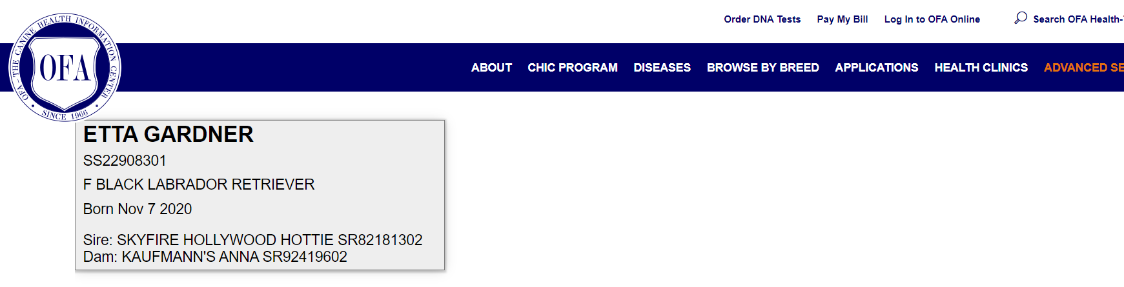

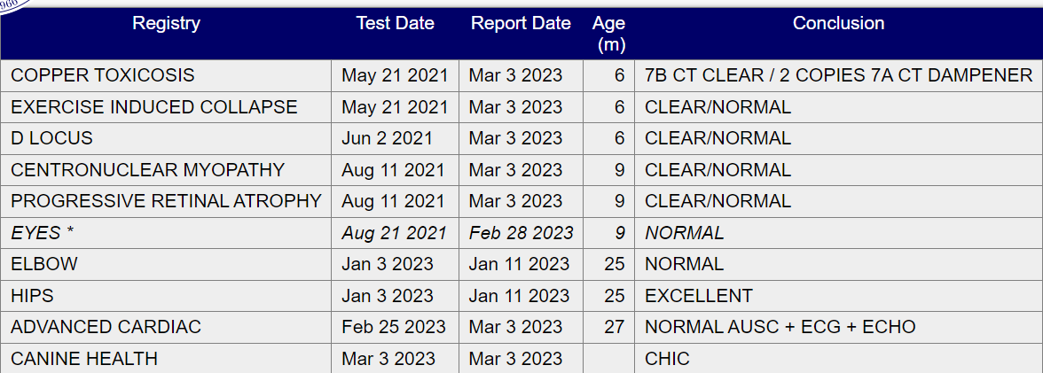

**Heart Clearance**

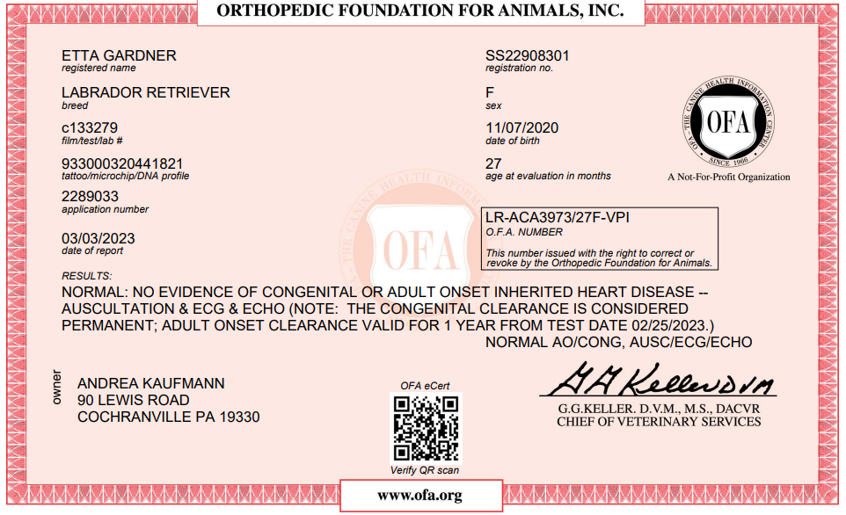

**Eyes Clearance**

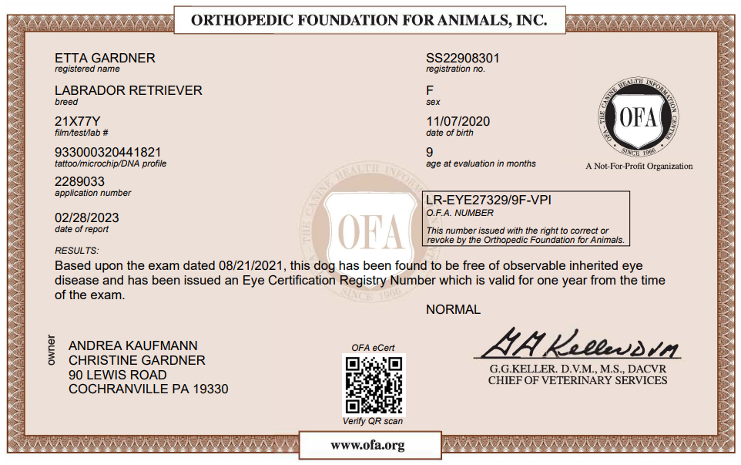

**DNA Clearances**

Centronuclear Myopathy (CNM)

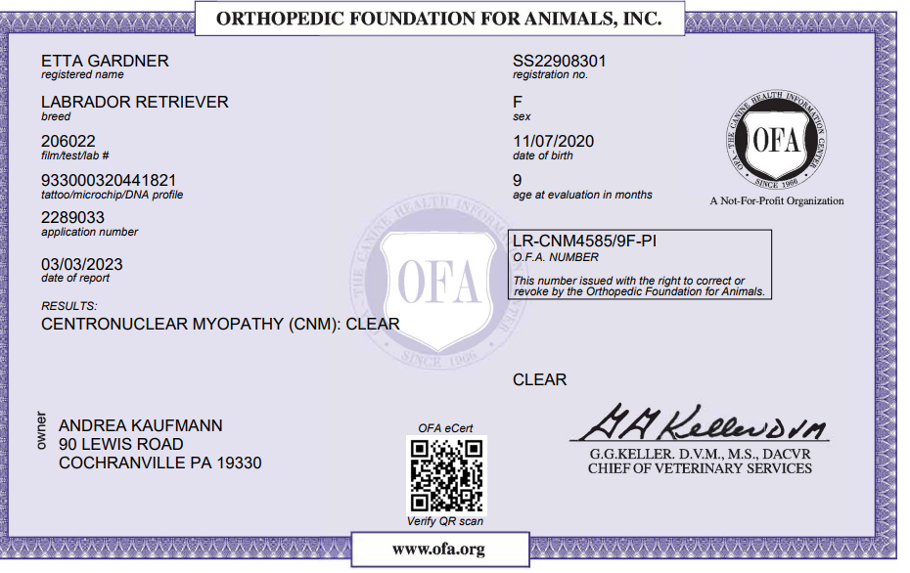

Cooper Toxicosis

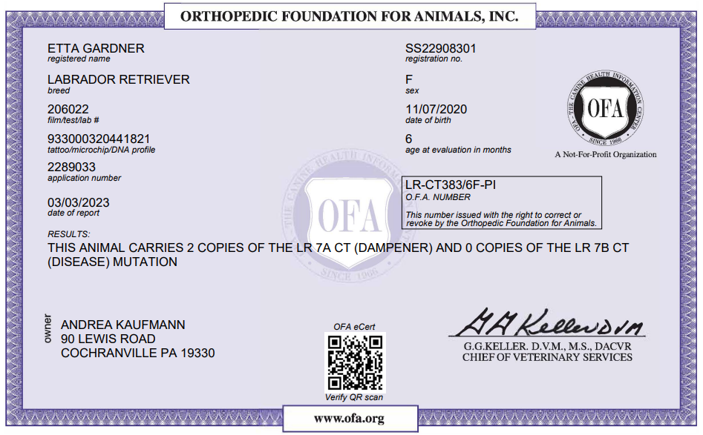

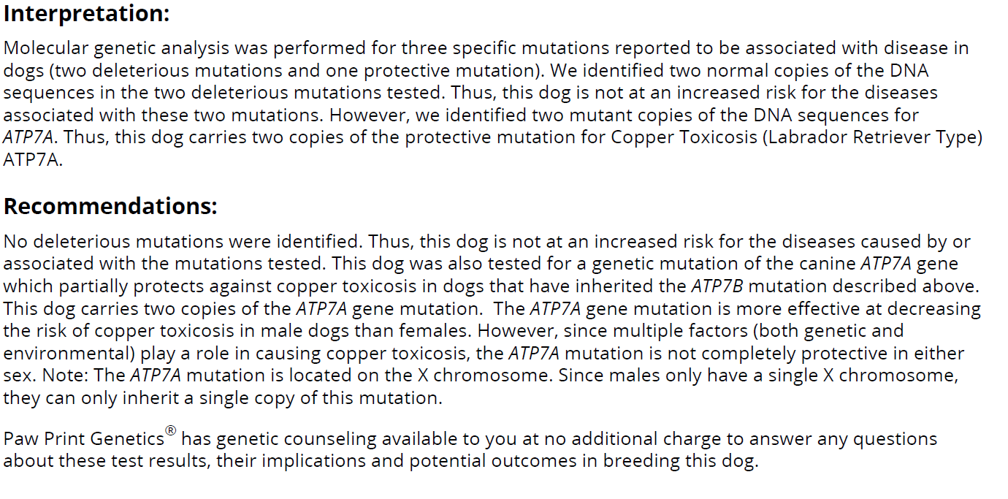

Exercise Induced Collapse

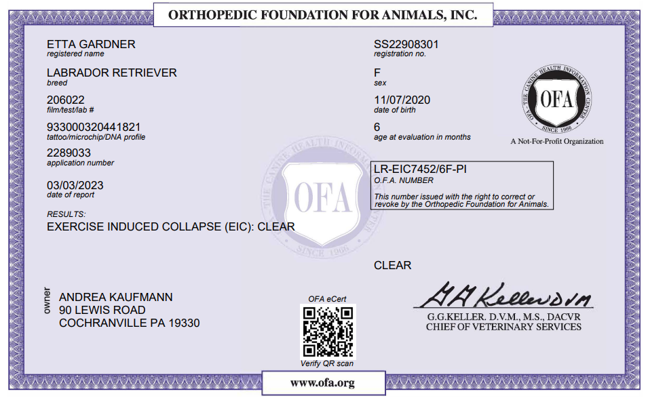

PRCD Progressive Retinal Atrophy

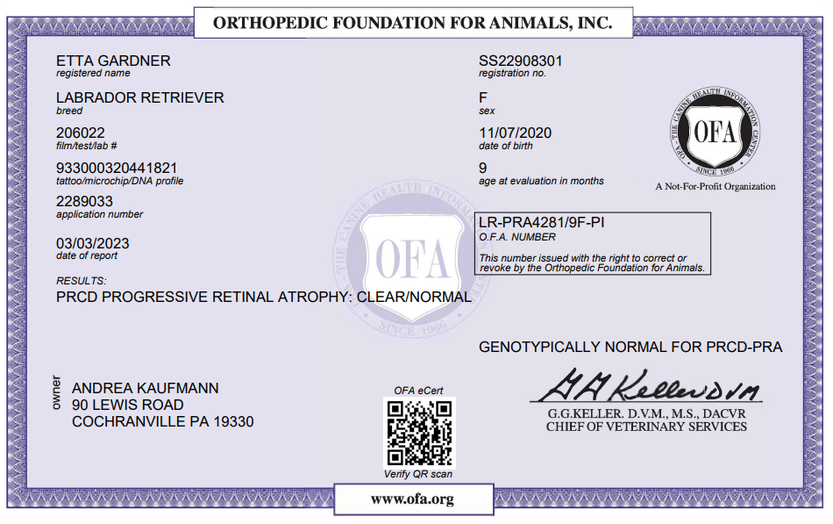

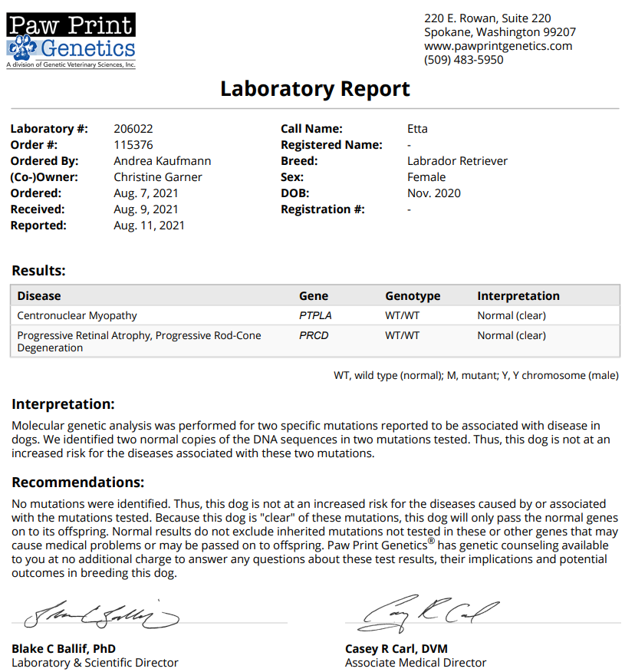

**Color Coat & Trait**

